That DDT Phenomenon
Read the article below (crew oxygen tank leaks) .... and then consider..

The difference between an inflight undetectable leak into an almost hermetically sealed flight-deck compartment (with the door closed/locked/infrequently visited) is perhaps the difference that makes the difference.... when considering the probable factors in an MH370 scenario.

Thinking here about the discussion in my MH370 Analysis on a pressurized flight-deck's DDT (Deflagration to Detonation Transition: aka "flash-over"). It's well known that when the oxygen concentration reaches 87% with an existing ignition source, a sudden and quite unexpected flash-over will occur. In the Apollo 1 command module fire that killed NASA astronauts Grissom, Chaffee and White, they were inside a 100% oxygen environment and a sparking switch, once made, triggered that conflagration. There is a difference in magnitude between sparking into a 100% concentration environment and “reaching” an oxygen saturation level that would trigger a DDT. Think about it.

Upon reaching that 87% oxygen saturation threshold, any existing ignition source will cause a sudden over-pressure (that sudden pressure-wave would, in the case of MH370, cause an oxy-leak blowtorch fire-weakened fuselage sidewall to suddenly blow-out - due to the pressurization differential pressure at cruise altitude) - and that MH370 fire to instantly extinguish due to that decompression i.e. the oxygen starvation at height. You could liken it to a limp explosion.... but a saturation level event would nevertheless also incapacitate the crew. Avionics and electronics damage would be very limited in such a flash-over ....and, in any case, many redundant systems would kick in….. and the airplane could fly on. This (and the reasoning behind it) is discussed in my article linked above.

Consider also that it may also well be an explanation for the crash of Egyptair Flight MS804. (19 May 2016 A320 regn: SU-GCC see link here )

Some argue that the aircon swap-out rate would negate any such oxygen build-up, but opinions differ on that. It’s a matter of the comparison rate between the oxygen leak influx and the aircon swap-out rate.

So, not unlike many other airlines with inveterate smokers amongst the flight deck crews, how close do undetected oxygen saturations come to becoming another MH370 - or alternatively, simply dissipate undetected (and harmlessly) during a cockpit meal delivery/toilet break in these crew supplementary oxygen tank emptying scenarios? i.e. as described in the attached article.

So, do MAS pilots ever light up at cruise-altitude for a surreptitious fag? It's been a poorly kept secret for many years that some airlines turn a blind eye to this practice.

Links: a. http://www.iasa-intl.com/folders/mh370/BusinessAustralian.htm#theTheoryPreface
b. http://www.iasa-intl.com/folders/mh370/DDT_Explosions.htm
c. https://en.wikipedia.org/wiki/Apollo_1
d. https://en.wikipedia.org/wiki/Deflagration_to_detonation_transition

https://onemileatatime.com/cathay-pacific-oxygen-bottles/

Who Is Emptying Cathay Pacific’s Oxygen Bottles?
August 31, 2019 by Ben (Lucky) 43
Cathay Pacific
Cathay Pacific has had a rough several weeks, following everything that’s going on in Hong Kong. Cathay Pacific’s CEO suddenly resigned, and staff have been warned not to participate in the “illegal protests,” or they could be terminated. Suffice to say morale at the company is low.
However, could frustration be causing someone to try to sabotage Cathay Pacific’s operations?
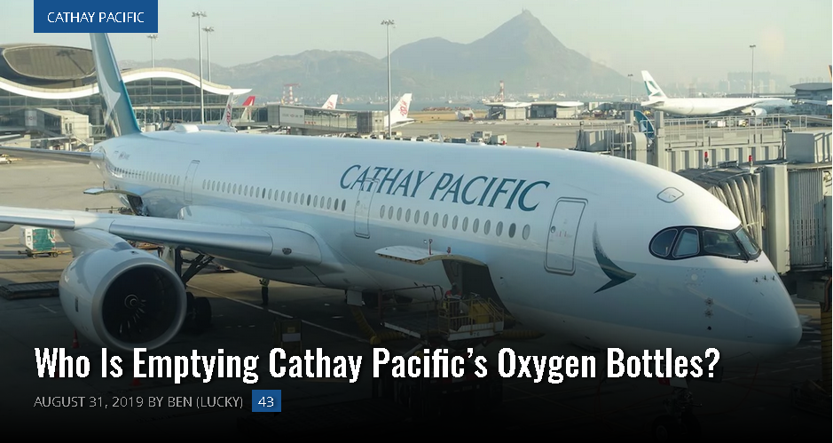

Cathay Pacific’s Empty Oxygen Bottles
As reported by Danny Lee at SCMP, Cathay Pacific and the Hong Kong Civil Aviation Department are now investigating something that has allegedly happened at the airline three times recently. Specifically, oxygen bottles on three different flights have now been tampered with, and were either partially or completely empty.
To start, on both August 17 and August 18, Cathay Pacific 777s flying from Hong Kong to Toronto landed with oxygen bottles that had been tampered with. Each flight had 22 oxygen bottles, and in total 13 bottles had been tampered with, between the two flights.
Then this past Friday, a third incident occurred. Prior to a Cathay Dragon flight from Hong Kong to Kuala Lumpur, an oxygen bottle was discovered to be empty. During the inspection the previous night, all bottles were full, which makes the airline wonder what is going on.

What’s The Motive?
It is important to clarify that in all of these instances we’re talking about oxygen bottles that are used in the event of an emergency, and not the plane’s primary oxygen system.
In other words, the odds of this actually being an issue are very small, since depleted oxygen tanks are only an issue in the case of an emergency. These are the tanks that the crew would use in an emergency, and not even the supply for the oxygen masks for passengers in the event of a depressurization.
I also find it interesting that in all cases only a minority of the tanks had been tampered with.
What I’m trying to say is that it doesn’t look like anyone is actually trying to cause great harm, since it’s highly unlikely they’d get to the point where this becomes the difference between life and death.
Rather it seems that someone is trying to send a message — and a very subtle one at that — about their frustration.
Something I’m not aware of, but would be curious to hear from experts on, is whether this is even definitely sabotage. In other words, what are the chances that these just malfunctioned for whatever reason, and given the situation at Cathay Pacific, people are just assuming it’s worse than it is? Could it be that in the third case they just hadn’t done a proper inspection the night before, and that’s what triggered all of this?
I’ll be curious to see if there are more instances of this, or if they discover who is behind this…
https://www.scmp.com/news/hong-kong/transport/article/3024596/probe-launched-after-oxygen-bottles-cathay-pacific-planes
Transport

Probe launched after oxygen bottles on Cathay Pacific planes found half-empty before flight from Toronto to Hong Kong
- All 13 discharged or partially discharged canisters were found on two flights earlier this month
- News comes as carrier bears the brunt of pressure from Beijing over staff who support anti-government protests in its home city

Danny Lee
Published: 9:31pm, 27 Aug, 2019

News
Cathay suspends dozens of staff after flights found with depleted oxygen bottles
3 Sep 2019
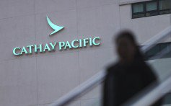

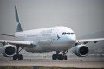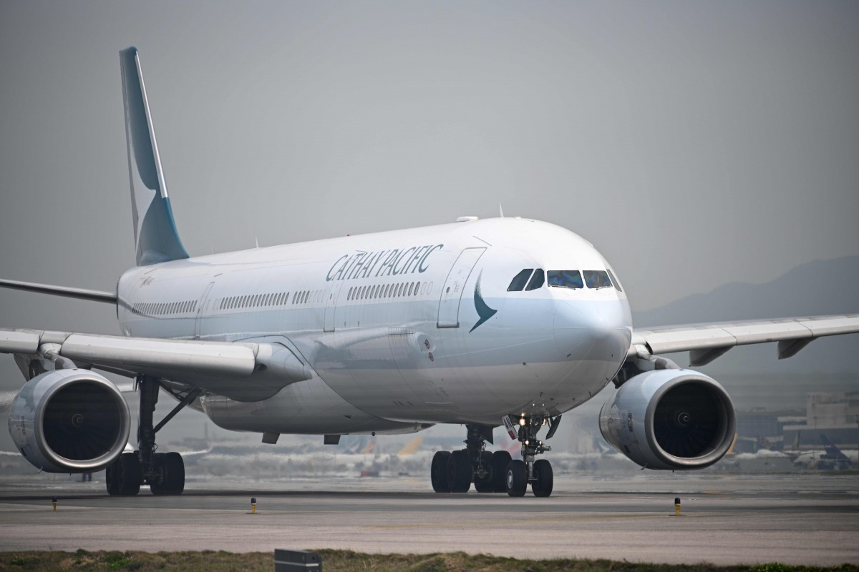
Cathay Pacific has recently taken a lot of heat from Beijing over the anti-government protests. Photo: AFP
Cathay Pacific Airways has launched an investigation after oxygen bottles on two of its planes were found to have been discharged and possibly tampered with.
The 13 discharged or partially discharged canisters were discovered on August 17 and 18. Of the 22 bottles carried on each plane, five were affected on one aircraft and eight on another.
Oxygen bottles are typically used by crew to move around in the cabin in the rare event of an emergency depressurisation.
The two affected planes were plying the same route, with problems uncovered during inspections when they arrived in Toronto. The Post understands the flight in question was CX826 from Hong Kong International Airport. The incidents took place on two Boeing 777-300ER aircraft, identified as B-KPY and B-KQB.
“Cathay Pacific confirms that a number of portable oxygen bottles stored on board two of its aircraft were found to be discharged or partially discharged while the aircraft were on the ground prior to departure in Toronto,” the airline said in a statement. “Cathay Pacific is taking the issue very seriously and has launched an internal investigation into the matter.”
Hong Kong’s flag carrier said it had discovered the issue prior to departure during routine preflight inspections. The carrier stressed that “at no point” was safety compromised.
DON’T MISS THE CRITICAL HAPPENINGS IN HONG KONG
Get our newsletter sent Monday to Friday
Top of Form
SIGN UP
Bottom of Form
By registering, you agree to our T&C and Privacy Policy
The airline added that the bottles were immediately refilled and checked by engineers before the flights to Hong Kong.
An aircraft engineer, who wished to remain anonymous, said the portable bottles are typically placed throughout the plane, and can be found closest to bulkheads or closets.
ADVERTISING
inRead invented by Teads

Cathay protest banned by Hong Kong police over safety fears

“Anyone can find these bottles if they look hard, because there are placards saying what’s inside,” the engineer said.
“Anyone actually can purposely deplete them. The attendants know how to use them. Just plug the mask and turn it on.”
The incident comes at a testing time for Cathay Pacific, though there was no indication it was linked to recent events.
The carrier has lately borne the brunt of pressure exerted on Hong Kong businesses over the city’s anti-government protests, with the mainland Chinese aviation regulator barring any of its staff who supported or were involved in the unrest from entering Chinese airspace.
The furore culminated in the resignations of CEO Rupert Hogg and one of his deputies, Paul Loo Kar-pui.
The company has since offered repeated public backing for the Hong Kong government.
On Tuesday, Cathay Pacific’s third-largest shareholder, Qatar Airways, said the airline’s future was not in any doubt.
“Cathay Pacific is there to stay, and to expand and to serve the people of both Hong Kong and China, as Hong Kong is an integral part of mainland China,” Qatar Airways’ chief executive Akbar Al Baker told Reuters. “We have no concern about the brand, we have no concern on the viability of the airline.”
This article appeared in the South China Morning Post print edition as: Discharged air bottles investigated by Cathay

