MH370 disaster: Australian report confirms electrical failure before disappearance
Sophie Aubrey | News Corp Australia
December 10, 2015 10:43AM

Topics
TravelWorld News
BURIED in the lengthy report released last week by Australia’s MH370 investigators is one crucial revelation: the aircraft suffered a serious technical problem triggered by a power outage.
The Australian Defence Science and Technology report officially acknowledges the doomed Malaysia Airlines flight suffered a sudden electrical failure before its disappearance on March 8 last year, the Daily Beast found. This backs the popular “zombie plane” theory, whereby the missing plane’s avionic systems are ravaged, rendering the flight crew helpless, and the aircraft continued flying on autopilot until it ran out of fuel.
A grim timeline reveals the power blackout occurred in a 56-minute window between the final scheduled contact from the jet’s Aircraft Communications Addressing and Reporting System and a failed attempt from dispatchers to contact the crew.
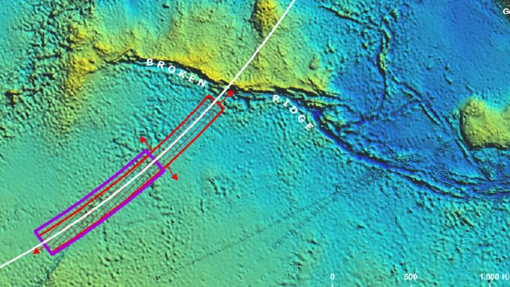
Investigation ... The priority search area is indicated in purple in the southern Indian Ocean.Picture: Supplied
The report provides four possible explanations for the outage, which place blame either on human intervention or a technical fault: crew action in the cockpit using overhead switches, a sudden error requiring an Auxiliary Power Unit to start emergency power, somebody pulling out and resetting circuit breakers in the equipment bay, or intermittent technical failures.
Whether one of these scenarios is correct can only be confirmed if the search for the lost plane is successful.
The power loss is said to have led to two of the Boeing 777’s automatic reporting systems and other vital functions to shutdown, likely causing panic in the cockpit as pilots tried to save the plane.
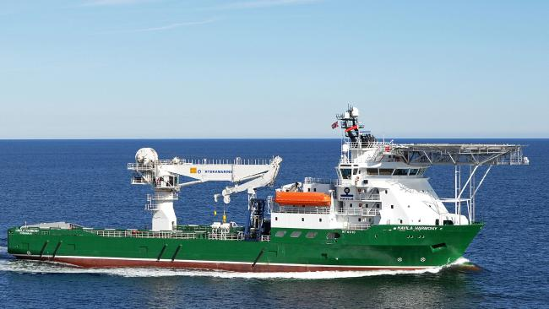Scouring ... The Havila Harmony is one of the ships searching for remains of the missing MH370 jet.Picture: AFP, AFP/ATSB
The timeline shows that after the electrical failure, at least one technological system managed to regain power 60 seconds later and kept operating, sending a series of hourly satellite pings for the remainder of the flight. Its final ping was sent 10 minutes before the jet crashed into the ocean.
In the end, a flight that should have taken just over five hours came to a halt over the southern Indian Ocean, seven hours and 38 minutes after takeoff.
The report explains “fuel exhaustion was probable” and it is believed “the right engine flamed-out (shutdown) first followed by the left engine” about 15 minutes later.
It is suggested that the “uncontrolled but stable” aircraft then circled downwards in a spiral and hit the water.
In this time, the run-down engines prompt the Auxiliary Power Unit to kick into gear, and it manages to complete a last transmission within seconds of the crash.
The evidence is described as “inconsistent with a controlled ditching scenario”.
Originally published as Was MH370 a ‘zombie plane’?
https://www.perthnow.com.au/news/mh370-disaster-australian-report-confirms-electrical-failure-before-disappearance-ng-db81004f8a694fbdb2c06e3ca216de9c

