France reopens MH370 investigation amid claims of Malaysian cover-up
aka https://tinyurl.com/ycb4cvdo
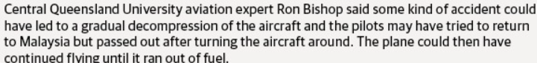
Ron
Cannot recall if I sent you a much earlier version of what's below, but I've updated it from time to time. Please feel free to read through it at your leisure and comment upon any aspect. If you have any French contacts, maybe you could forward it to them. Given the caliber of the Final Report I doubt that any Malaysian destination would achieve much – but feel free.
Regards
John S
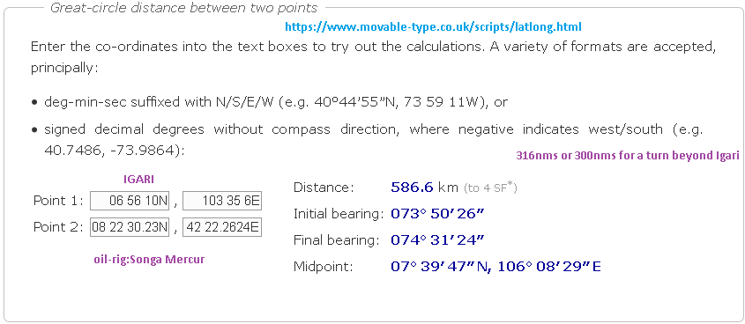
Ron
FYI
With regard to the waypoint Igari to Songa Mercur oil-rig distance and the feasibility of Mike McKay (the oil-rig worker who claimed to have seen a distant fire in the sky at around the right time), it's become the unlikely "beyond the visual horizon" issue of the 300 nautical miles for a turn-back beyond waypoint IGARI and halfway along the further 33 nms to the next way-point BITOD. However when one keeps in mind that the actual turn-point location is still in question and that the transponder was OFF (with no skin-paint), the physical location of that turn-point is quite debatable. It could have been as close as 260 nms from the oil-rig. That puts it in the bailiwick distance for a high-cloud reflectivity sighting due to empty-field myopia (a visual acuity night phenomena which is explained in one of the links [#15] in the menu below). The effectivity of night empty-field myopia is very dependent upon the darkness of the night in the direction of interest, the degree of dark adaptation of the observer and the brightness of the flash impinging upon the retina via a fully dilated pupil. I myself have seen photoflashes of 200 million candlepower from that sort of range during night SAR from a P3 Orion. So I am keeping an open mind on Mr Mike McKay's sighting, particularly as early reports had MH370 in an altitude excursion to somewhere above 40,000ft once acquired by military radar with its rudimentary height-finding capability. I brought this up with Victor Ionello, but he's not open to alternative theories - and in fact refuses to peruse, let alone embrace or consider them. However IMHO the sequence of events leading to the disabling and eventual crash of MH370 is easily explained by considering some propositions peculiar to that Boeing Model.... e.g. the PFCS, as well as the different style of integrated electrical system in the 777 (that was first developed for the B717 - see this link and below)

Aero 07 - 717 Integrated Electrical Power System - Boeing
www.boeing.com/commercial/aeromagazine/aero_07/intelec.html

Aero 07 - 717 Integrated Electrical Power System. The integrated electrical power system aboard the Boeing 717 is a first in the commercial aviation industry. This simplified system greatly reduces the number of current transformers traditionally found in electrical systems. I.E.P.S. was further developed for the 777.
Furthermore, when considering a DDT scenario (Deflagration to Detonation Transition - item #28 on Menu below), the overpressure generated by the leaking oxygen reaching the 87% enrichment level for a DDT trigger would easily hole a focal area alongside the pilots' side consoles that had already been weakened by any oxygen leak fueled fire (i.e. a thermic lance ignited by any sparks from a radio-select/intercom module/panel, a windscreen heater terminal block or any other sourced spark or arc). Or a frequency change (as in “Goodnight, Malaysian 370”). Keeping in mind that an increase in oxygen levels is odourless and invisible, it could well have been the case that the resulting decompression and pilot hypoxia would have been well after a fire-fighting effort of anything up to 5 or 6 minutes along their existing course - before the oxygen built up to trigger levels - despite the aircon swap-out rate. Remember that oxygen does not itself burn, it merely supports combustion on exposed surfaces, albeit somewhat fiercely. The denouement happens when the DDT flash-over's overpressure (as supported by the cabin pressure differential) blows the hole in the side of the 777's flight-deck and the fire is instantly snuffed out (as well as the pilots' lives- probably after they had initiated a turn-back towards the Malay Peninsula, as a result of the DDT event).
The transponder going off-line might have been a function of the DDT flashover (a temperature peak), or a manual monitoring switch-off of some busses or of any items in the vicinity of the fire. The main document (http://tinyurl.com/or9bzf2) describes the distinctive characteristics of the integrated electrical power system and the likely effect of a DDT flash-over in a highly plasticized cockpit. The plastics constitute a totally different ball-game once the older-style solenoid-held metal switches are out of the picture. Plastic push-buttons and plastic paddle switches latch in an entirely different way…. and many of their underlying system resets are quite automatic. A DDT flash-fire, although a mere detonation of microsecond duration (and well-short of a destructive “explosion”) would have quite a disruptive (but not necessarily a destructive) effect upon the modern plastic cockpit, with its myriad of fallback redundancies and automated system resets.
Of course, have the same emergency in an A320 (Egyptair’s MS804? …the May 2016 crash in the Med short of Cairo) and the outcome would be entirely different - due to the respective flight control system’s individually unique idiosyncrasies (i.e. Airbus vs Boeing). The 777’s Primary Flight Control System (PFCS) has limitless fall-backs and fail-safe redundant pathways - as well as an inherent innate stability to enable autopilot-off protracted straight-line flight due to its reactive nature for non-pilot -selected attitude changes. The Airbus philosophy is nowhere near as forgiving once the electrical failure cascade starts. I wonder how many pilots are familiar with the fact that Halon extinguishers are quite ineffective against either Lithium battery or oxygen-fed fires? In fact, unless the pilots are on oxygen themselves, the Halon can quickly induce cognitive impairment…. but will only minimally delay oxygen enrichment levels reaching the DDT trigger-level on an enclosed flight-deck..
DDT on Google = link
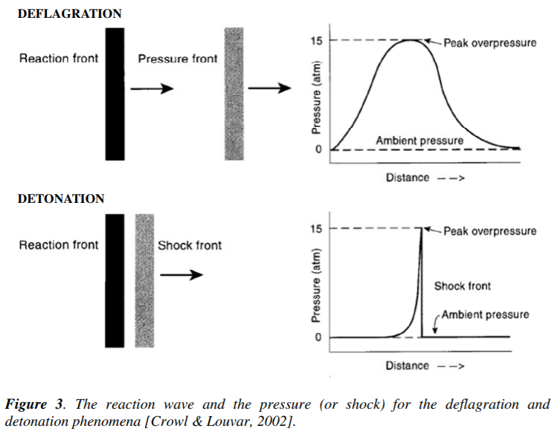
The pressure fronts produced by detonations and deflagrations are markedly different. A detonation produces a shock front, with an abrupt pressure rise, a maximum pressure of greater than 10 bar, and total duration of typically less than 1 ms. The pressure front resulting from a deflagration is characteristically wide (many milliseconds in duration), flat (without an abrupt shock-front), and with a maximum pressure much lower than the maximum pressure for a detonation (typically 1 or 2 bar). The behaviors of the reaction and pressure fronts differ from those shown in Figure 3 depending on the local geometry constraining the fronts. Different behavior occurs if the fronts propagate in a closed vessel, a pipeline, or through a congested process unit.
A detonation wave is a very sharp, very high pressure, shock-wave travelling through an explosive material. ... Almost all ordinary fires can be considered as deflagration waves: the flame-front in a candle is a deflagration moving through the burning gases at subsonic speed.
Detonation is a type of very finite explosion. Both detonation and explosion occur when the volume increases rapidly and there is high release of energy. Detonation is more intense as it produces supersonic shock waves whereas explosion has less intensity and produces low intensity destructive shock waves.

MH370 - not really a mystery (10August 2018 update -29 below)
A canvas of the possibilities, culminating in an exposition (see entry #11 below in main text, et seq)
on the likely sudden developments aboard Malaysian Flight MH370
https://bit.ly/2J1mR8U
Precursors and Precedents are always the tell-tale arbiter
1 | this document: (correspondent feedback is at the bottom of this document) | http://tinyurl.com/or9bzf2
2 | Executive Summary (downloadable Word Document) | http://tinyurl.com/gqpnwcn
3 | Short Synopsis: | http://tinyurl.com/lh7sv2g
3a | An Alternative Ignition Source (#1) | http://tinyurl.com/jbswxq7
3b | An Alternative Ignition Source (#2) and (#3) | Flt Deck and cabin oxy hose fires
4 | A Further Dissection of MH370: | http://tinyurl.com/qz5f9au
5 | An Oxygen Flare time-line | http://tinyurl.com/otpncea
6 | That Tell-Tale helical Spring | http://tinyurl.com/p4ncpf9
7 | Filling in the 777 Blanks | http://tinyurl.com/omh3qc9
8 | Downloads - videos | http://tinyurl.com/pew2bot
9 | Downloads - imagery / pdf etc | http://tinyurl.com/nvgseqv
10 | Notices of Proposed Rule-making for Boeing and Bombardier oxygen hose fires | http://tinyurl.com/odp5v52
11 | Losing and Regaining Satellite Comms - The SDU Quandary and Solution | http://tinyurl.com/j24f5ac
12 | That Audio Select Panel's electrical short (in prior O2 fires) | http://tinyurl.com/ovhgnpy
13 | August 2016 - AD proposes removal of electrically conductive oxygen hoses from 777-200 and -300 pax compartment due to a propensity to catch fire. | http://tinyurl.com/hse8bq3
14 | A Lectromec Solicitation (...a burnt piece of MH370 interior panel is found) | http://tinyurl.com/hd3awyv
15 | The Oil-Rig Worker's sighting and the phenomena of nocturnal "empty field myopia" | link + link
16 | In support of the MH370 Oxygen Flash Fire Theory (Deflagration to Detonation Transition link) | link
17 | MS804 -Egyptair A320 (Oxygen fire? You be the judge)  The MS804 Back-Story? | link 1  link 2
18 | The ABX Air 767 Oxygen Fire | http://tinyurl.com/ybwmf25o
19 | One Surprising 777 Oxygen AD - another Unraveller | http://tinyurl.com/y7j3e99z
20 | More Airliner Oxygen Fire Airworthiness Directives (2018 variety) | https://tinyurl.com/yd55xqf7
21 | An Official Conspectus of Airliner Fires | download link
22 | Nefertiti on fire | Video of SU-GBP Cairo fire
23 | Yet another LP Oxygen hose fire AD (link) released 15 May 2018. Note also that Inaccessible Aircraft Fires regs didn't apply to the 777 (exempted - link). 777Crew oxygen Bottle (wiring beneath)  and permanently banned (link) again from Pprune with posts deleted.... for drawing attention to it - all threads padlocked (link) | AD 2018-09-12 with commentary  expunged Pprune post (link)
24 | Deflagration to Detonation Transition (The Tech Term for an Inflight Flash Fire in an Oxygen Enrichment Environment) | link
25 | You just never know what's happening under your feet | link
26 | The Oil-Rig Worker's Sighting (valid or invalid?) | link
27 | French BEA Finding is that a Cockpit fire quickly took down A320 Flt MS804 in the Mediterranean | link
28 | An Inquiry into Deflagration to Detonation Explosions (to TSB of Canada) | link
29 | French Gendarmerie Inquire into Nefarious aspects of MH370 Event | link

Return to main menu: http://tinyurl.com/or9bzf2

