Every Breath You Take…
Executive Summary - The Likeliest Cause of the Loss of Flt MH370
An explanation based upon Precedent, incorporating Known Facts and with very Limited Conjecture ( main document is at: http://tinyurl.com/or9bzf2 )

If one discards the unsubstantiated allegations of rogue pilot participation and the actions of a suicidal hijacker, the other facts loom much larger in context. Firstly, whatever happened on that 777 flight-deck occurred very quickly. It was very unlikely to have been a bombing. Because the aircraft flew on almost totally incommunicado for many hours after the "event", that event almost defines itself. Firstly, it affected a number of electronic systems and/or their flight-deck located electrical supply or (left largely unconsidered) their "controls". Whatever "it" was, "it" also affected the pilots to the extent that their ability to react was quite evidently injury and/or time-limited. It similarly affected and incapacitated passengers and cabin crew aft of the locked cockpit door. Mass incapacitation of this type, that leaves the aircraft capable of flying onwards as a "ghost flight", is limited to a large scale gassing or (far more likely) a rapid or explosive depressurization. Toxic gassing via a device is highly unlikely as it would not have disabled electrically powered systems. The funnel to a likely explanation circles the vortex of a mass hypoxia causation. For this to have happened, the pilots' inability (for some good reason) to "get on oxygen" and then "act appropriately" must be a central theme.
So the sole remaining contender is depressurization - and it's likely to have been rapid or explosive. Because of layering, windshield blow-out is also highly unlikely - as well as being an issue that would be unlikely to cripple selected electrical systems. Any depressurization due to a pneumatic, mechanical or particular discrete system failure or switch mis-selection in a stable cruise is highly unlikely..... as is the likelihood of such an event preventing pilots from getting onto oxygen and taking the universal standard recovery action of rapidly descending to a life-sustaining altitude (as well as advising ATC of their plight as a high priority). One sole explanation that remains credible - as a logical sequitur - is therefore that of a fire involving the pilots' supplementary oxygen system.
Engine-related events aside, most airborne fuselage or cargo compartment fires involve the fire triangle of fuel/oxygen and ignition via wiring fault or cargo hazard. Extensive experience in this field has demonstrated that the intensity and spread-rate of such aircraft fires is never so fast that pilots are unable to converse with ATC or other aircraft. This maxim even applies to uncontrollable Lithium Ion battery fires, dating back to the SAA 747 Combi (1987) and the Flt UPS6 747 crash in Dubai (with numerous other Li Ion battery fire events in the intervening period).
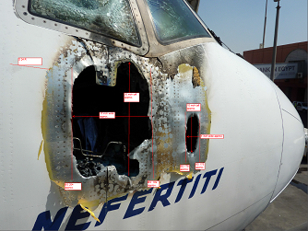
Wiring-related arcing that spreads behind cabin linings (such as on Swissair 111) occur over a finite time.... and can, over time, become both aircraft systems and pilot disabling. Industry-wide measures for manufacturer and ongoing in-service inspections under the aegis of Electrical Wiring Integrity Systems (EWIS) - since TWA800 and SR-111 - have ensured that wiring insulation types and wiring loom stand-off standards and intense examinations of aging aircraft now make such fires relatively rare. Yet they do still happen due to chafing and missing stand-offs (found in ABX Air 767 as well as Egyptair and MAS 777 fleets). However, when these electrical fires happen, their spread is limited due to the ongoing swap-out of inflammable thermal acoustic blanket insulation and fire/smoke checklists that now pay due regard to airflows behind cabin linings. Indeed, it is apparent that the MH370 inquiry to date has been quite unable to locate a possible/plausible specific electrical failure mode for the systems simultaneously (and event-coincidentally) dropping out on MH370. But there actually is one, yet it is quite unapparent, unless seen against a background of the overall event (...more on that theory below). To summarize, there is but one fire threat that is quite extant and that covers all the bases addressed thus far (but it's also one that is fortunately and usually a rarely experienced phenomenon airborne). It is that of a cockpit oxygen fire. It fits the bill for MH370 - in all respects.
Such fires have resulted in the destruction on ramp of a number of aircraft (777, 767, 737, CRJ2, P3 Orions, IL-96, C135 etc) within the last decade. Some of these fires were related to electrically conductive helical anti-kink springs in the cockpit oxygen system's hoses... and the lack of a corrective follow-through by Boeing and the FAA. In fact, the 787 Airworthiness Directive to remove the dangerous hoses from types other than the 777 (and amazingly, including the 787) came out well after MH370 disappeared (in an omnibus FAA directive based upon implementing a similar series of "late to the party" low-key Boeing Service Bulletins and letters to Operators).
Consider events such as the 17 Nov 2009 depressurization of the QANTAS 747 VH-OJK. When an oxygen cylinder failed explosively and blew itself through the side of the aircraft at the starboard leading edge wing-root, it crippled some aircraft systems but did not affect the pilots or result in fire or any extensive electrical systems disruptions. The ATSB, after extensively testing bottles from the same batch, simply called it "a unique event" and perplexingly, closed the case. Notwithstanding that scenario, by far the most destructive oxygen-stoked events are fires that are electrically initiated and pressure-fed (the only oxygen-flow shut-off being for replenishment purposes at the bottles themselves - and quite remote from the pilots' ability to control). .... i.e. there are no intermediate excess flow-rate based auto-shut-offs in any airliner type (i.e. one that's capable of interdicting unfettered high-pressure oxygen flows into the flight-deck). Once fire has broken out and either pilot's regulator is in the process of a self-destructive conflagration - there is nothing that can inhibit such oxy-dumping flows from boosting any oxy fire outbreak. It's a very conclusive emergency from the outset, particularly in the cruise.
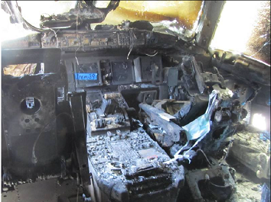
After a 30 minute fire
(note RH side console - hull holed)
In the unpressurized ground-bound instances cited above, fire extinguishers failed to have any effect at all. In the 767 fire, even the foam from the firetruck’s SPN (Skin Piercing Nozzle) failed to affect the outcome. Besides the electrically conductive helical anti-kink hose-springs, there are a number of adjacent or proximate sources of ignition (windshield heater terminal block fires, improperly applied lubricants, metal swarf, regulator internal lighting plates, wiring physically attached to oxygen lines, reading lights, oxy-mask mike's wiring, audio-select panels etc etc), i.e. sources that can conceivably cause an outbreak of an oxygen-supported fire. The NTSB remarked in one such fire accident report that stainless steel oxygen lines were actually very remotely earthed to the airframe’s outer skin over their entire length due to rubber-lined stand-offs being standard - all the way from the bottles to the blow-out pressure relief discs located on the airframe's side externally (i.e. the discs that can rupture to dump overboard any excessive pressure in oxygen systems). This previously unrecognized anomaly was nominated by the NTSB as a hazard that existed on most (if not all) airliner types.... as a design flaw that had universally eluded FMEA (Failure Mode Effects Analysis) design studies. In the Swissair 111 Report, the Canadian TSB pointed out that the MD-11's stainless steel oxygen line end-caps were made of low melt-point aluminium and thus were very susceptible to fire (in comparison to the stainless steel oxy line's very much higher melting points) – and were thus inviting oxygen participation in any wiring fire behind cabin linings. Oxygen (LOX or gaseous) can (and always has been) both a blessing and a curse. It lurks as both a possible threat and ultimate salvation. Its long-standing traditional system design (for pilot succour) needs a safety review. The "peril factor" may be quite latent and thus down-played, but the possibilities are very real.... and the high hazard area of "the cruise" is around 90% plus of the total flight-time for long-haul. That’s a significant exposure quotient for that auto-dead area called hypoxia-ville. A Helios Airways 737 and a pro-golfer’s Learjet and a Beech 200 Super KingAir out of Perth all fell foul of that insidious trap. “Every breath you take” is wholly reliant upon very few intermeshing systems. Once they come seriously unglued, everybody dies.
Once had a de-icing blade-cuff fly very noisily off an Orion’s #3 engine prop at 30Kft and it caused such a rotational imbalance that we couldn’t read the engine instruments. Nothing was showing up elsewise, so we sent the #2 flight engineer down back to take a look at the wings. From the RH waist window, he saw a “loss of solidity” in the #3 prop’s arc, so we shut that one down and the severe vibes stopped. However, we’d entirely missed the fact that anybody in the loo would’ve died as that flying blade-cuff had pierced the fuselage and we were quickly losing pressurization….and as a crew, getting mentally “fuzzy”. We were losing the plot - all 16 of us, by concentrating upon the severe vibrations and identifying the source, whilst punching out a Mayday call. That’s how easy it is to fumble that hypoxia ball in a very short time-span. Unfunnily enough, that was the same 92Wing P-3 Orion (A9-300) that burned down on the RAAF Edinburgh tarmac in an oxygen fire some two years later. It actually and literally is “every breath you take”, but the rapid onset loss of awareness is the real killer.
As many (but not most) would be aware, oxygen itself does not burn - but in high concentrations it stimulates fire greatly, often with ignition being solely due to a component being heated to relatively low temperatures (due arcing, conduction, shorting or adiabatic compression). Flight-decks are quite vulnerable to high rates of oxygen enrichment build-up in such oxy-leak circumstances, due to the locked cockpit doors and a quite low swap-out rate of air in the flight-deck air-conditioning system.

Deflagration to detonation transition - Wikipedia, the free encyclopedia
Deflagration to detonation transition (DDT) refers to a phenomenon in ignitable mixtures of a flammable gas and air (or oxygen) when a sudden transition takes place from a deflagration type of combustion to a detonation type of combustion. The effects of a detonation are usually devastating.
My version of the possible MH370 oxy-fire climax is being called a "flash-over" but admittedly it's a little more unique than a common garden variety "flash-over" or backdraft that most metropolitan fire-fighters would be familiar with. DDT sounds more like the scenario being depicted.
https://en.wikipedia.org/wiki/Deflagration_to_detonation_transition
Oxygen fires can start in such an environment and be relatively subdued initially (i.e. localized in the vicinity of one pilot's side-console mounted regulator). As the regulator burns, it self-destructs and then increasingly acts as a focused blowtorch against the side of the hull. Eventually, as the regulator's flow-limiting function is compromised, the oxygen enrichment process will increase to an unabated full flow and then suddenly initiate and space-fill in a very short duration "flash-over". Recall the deadly Apollo 1 capsule simulator fire as an exemplar (from the first call of "fire", in their 100% oxygenised environment, to losing communications with the astronauts … was 17 seconds). That eruptive sheet of flame will affect aircraft operation in at least four different ways:
a. Pilots will suffer some lung-searing and blinding effects and one of them would suddenly be robbed of any residual supplementary oxygen from his unaffected regulator during a flash-over (but understandably, they may not realize this at the time - as they may have already donned masks due to smelling smoke or hearing an arcing event). Oxygen as a factor in their initial emergency would not be readily apparent..... and pressurization would not yet have become an issue. It is suggested that any such climactic flash-over would be time-limited by its natural consequence (see item c. below). The overall destructive effects upon the flight-deck would similarly be mitigated by what likely happened next….. in short order. But, in the interim….
b. Plastic switches and their surround mounts of dissimilar plastics will suffer distortion (and this to different degrees due to their positioning, aspect and possible shielding by pilots' bodies etc). Some switches may actuate, solenoid-held functions may de-latch, push-buttons might simply lose illumination individually or en masse; push-buttons may fuse together or with their surround mounts. Some LCD/LED screens and associated keypads may be affected and some circuit breakers could trip thermally (or pop due to flash-over induced shorting of control switches), disabling some systems but equally, not affecting all that many (particularly not those that are remotely located in the Main Electrical Centre beneath the cockpit). Many critical systems are failure-proofed by multiple redundant paths for their power and then there are those that are bolstered by duplicate mutual support and voting protocols). The invalid aural triggers as a meltdown cacophony? That’s another discussion… but it could be audio mayhem. Metal toggle switches are far less susceptible to such an event (if indeed they are at all), but there's very few of these in modern day cockpits. Push-button plastic switches that indicate their system's status (or show a comms frequency or transponder code, say) by self-placarded illuminating acronyms (i.e. upon the face of the switch)? They may prove confusing to pilots in extremis (who may punch these unlit buttons looking for a correct (or at least "some") lit indication - but by doing so, unwittingly disable that system).

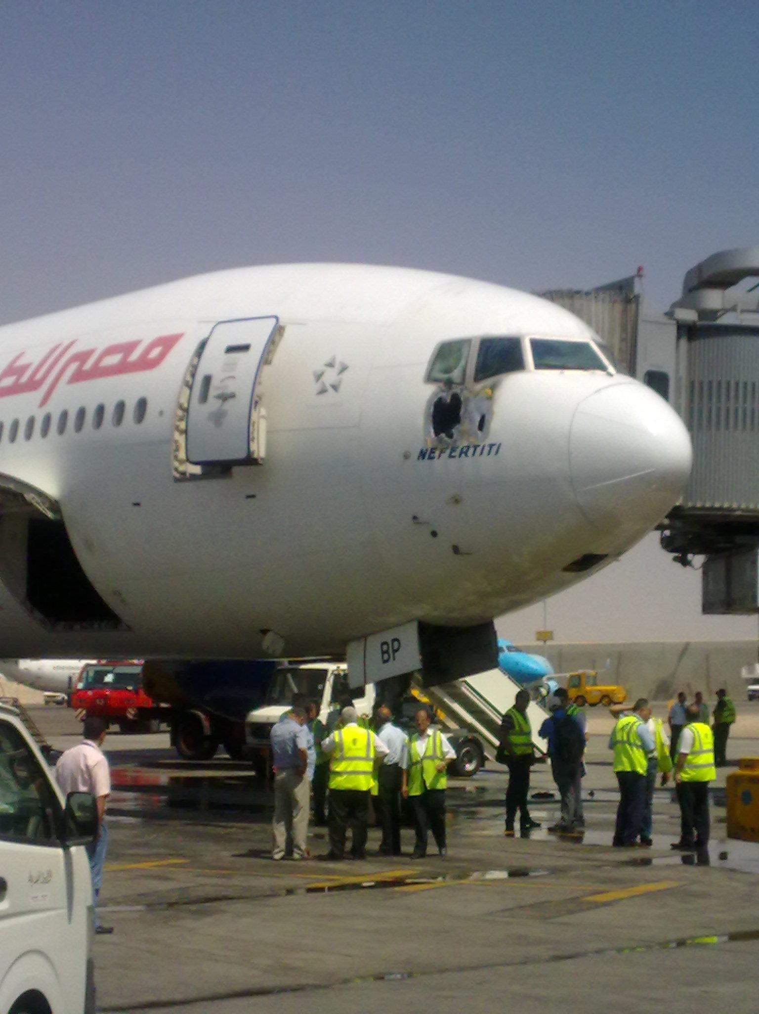
Egyptair 777 (Cairo)
c. The overpressure peak of an oxygen flashover would likely cause the weakened blow-torched hull area adjacent to the pilot's side console to rupture (per the Egyptair 777 and ABX Air 767 imagery) - and bring about an instantaneous loss of the oxygen enrichment due to that holing. Note that this development would in turn be the "perfect squelch" - for there to be no further ongoing flight-deck fire (i.e. nowhere near as destructive, due to the limited duration, as can be seen in the on-ramp events' imagery below). It's doubtful that any smoulder at all would continue after the depressurization - as the aircraft pressurization's differential pressure, once augmented by the flashover's over-pressure, would have blown the hole's jagged lips outwards and it would now be scooping in the thin ambient air at 35,000ft. If the oil-rig worker saw what he says he saw, it was likely to have been the flash-over itself.
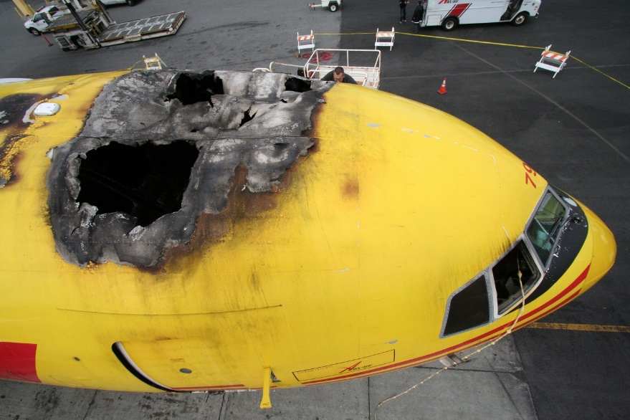
ABX Air 767 (San Francisco)
A nocturnal visual acquisition phenomenon called empty-field myopia makes this sighting quite plausible. On a dark night, one's eyes will always auto-focus just a few metres ahead. A bright flash of finite duration many hundreds of miles distant will instantly change that focus to a clear retinal image of that flash and enable ongoing observation of the source, despite the intensity having abated.
d. A rubber jungle drop-down of masks in the cabin would've been the sole indication of any such event happening forward of the cockpit door. It's not as if a flash-over DDT would be in any way noisily explosive (beyond a noticeable muffled thump perhaps). Dense smoke may have resulted and persisted for a short period however.
An explosive depressurization is a much more disorienting event than a rapid or gradual loss of cabin pressure. It's likely that the seated pilot who hadn't been forced from his seat by a side-console fire would have been "distant" and protected enough to survive the flash-over by being masked up, and breathing some residual oxygen through his unaffected regulator. After the flash-over, (or just as likely, just before it), he could have used his limited time of useful consciousness to commence a turn-back towards the Malay Peninsular and disconnect the autopilot, entering a steep nose-down attitude to accelerate into an SOP maximum rate descent. However, at that point, all system oxygen having been exhausted, he would have passed out, relaxed his forward pressure on the yoke and the 777 would have pitched up sharply (due to speed increment and trim) - and stalled out somewhere above 40Kft. That would have been the commencement of MH370's ghost-flight.
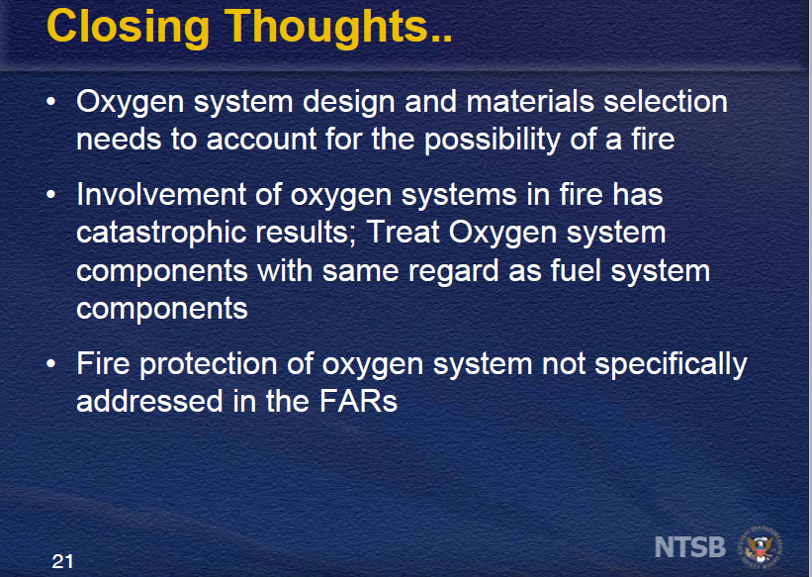
A few flight attendants may have lingered on for a short period by using unused drop-downs and portable oxy-bottles. However, that's debatable given the physiological effects of explosive decompression and an achieved peak altitude of over 40,000ft.
The 777's "Active" Primary Flight Control System (AFCS) is a very capable and totally self-redundant fly-by-wire system. Autopilot OFF, it will recover itself quickly (from a post-stall pitch-down phugoid) back to wings-level flight in trim - after a minimal number of diminishing amplitude sinusoidal oscillations in pitch. Laterally the AFCS will respond to a gust-induced minor wing-drop even more quickly than a pilot could. As fuel burnt off, 9M-MRO was quite capable of an enroute cruise-climb - in fact able to achieve an overall range to fuel exhaustion much greater than it's being given credit for in the search area determinations based upon a constant cruise height.
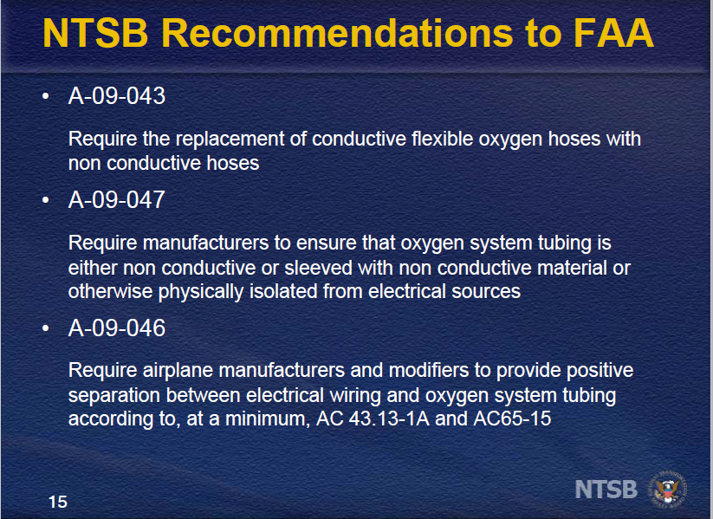
However, given the mid-March seasonal positioning of the ITCZ (Intertropic Convergence Zone), it is more than likely that 9M-MRO bumbled into the odd thunderstorm during its Straits (and tip) of Sumatra tracking - and after a few wild moments, got spat out each time on a new heading, quickly recovering itself to steady wings-level climbing flight on its new track. It would've done the same again at the next Cumulonimbus (CB) encounter..... perhaps quite a few times. Inside the 350km latitudinally wide ITCZ band, the CB cloud tops can get up to 55,000 feet - and to avoid these active cells, you need weather radar and an alert pilot. However once 9M-MRO was fortuitously spat out on a Southerly heading, it would have been quickly thereafter "bullet-proofed" against any such further encounters. Why? Because once outside that ITCZ band of hyper-active convective activity, and south of the Equator, it would have been far less likely to bump into any enroute build-ups at or above its cruise height (which was always increasing anyway, as fuel burnt off and ambient temperatures dropped). CB's south of the equator would also have been much more scattered geographically and topping out below 35,000ft. 9M-MRO's tracking would've then been a meander with a maximum plus or minus 5 degree mean heading divergence.... in other words, it was effectively on a straight-line bee-line to splashdown.
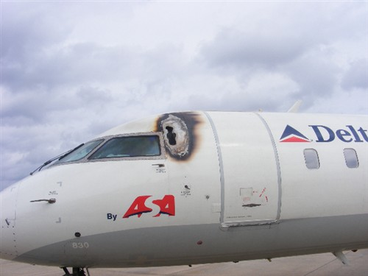
CRJ-200
Longitudinal trim would've been quite static, there being no fore-aft movement in the cabin. Alternatively, if there'd been any earlier "backrush" by pax away from smoke emanating from the flight deck or the forward cabin linings, the resulting trim-state in pitch would have been "pro" a continued ascendant flight profile towards its thrust-weight limited ceiling. A final achieved height of around 43,000 ft is a possibility for the fuel exhaustion finale. Any other airframe (i.e. one without an "active" flight control FBW system) would have spiraled into the ocean quite early on.
Boeing's 777 AFCS also sports an inbuilt thrust asymmetry compensation capability, so there's no guarantee that the first engine flameout would have resulted in anything much more than a slowing descent drift-down on a fairly stable heading at the one g stall speed (plus an inbuilt gust factor safety-speed margin). Ultimate engine-off impact with the ocean, with APU and RAT running, would have been nose-high and wings level, allowing that aberrant 777 to remain relatively intact and shedding very few airfoil excrescences (i.e. flaperons and some tail-feathers possibly). It may well have floated on, quite whole and integral, at or near the surface, for days or weeks, courtesy of the empty wing-tanks and complete with its human complement - before settling to the bottom. Once bottomed, currents would have led to a gradual terrain-induced break-up over time followed by the shedding of many internal non-structural linings and furnishings as flotsam. It's also worth noting that the impact-initiation of battery-powered ELTs (that punch out a traceable SOS to COSPAS-SARSAT satellites on 406mhz) has a proven very high failure rate in airliners. In such circumstances, air-searchers sorely need that ELT signal's info to localize to an impact area such that ongoing ULB (Underwater Locator Beacon) searching by surface vessels, sonobuoys or submarines will be fruitful. Any break in that chain of localization links will always lead toward the current prototypical search frustration imbroglio. And it's not as if MH370 isn't eminently "repeatable".
The leaps of faith required to endorse this theory are very few. Because the theory was internet published in its basic format in early April 2014, and later developed and widely disseminated by me within the industry, it is quite unsurprising that the last Malaysian Interim Report under ICAO Chapter 13 has claimed at the outset that 9M-MRO's flawed oxygen hoses had been replaced. That claim is very reminiscent of the China Airlines assertion that its tail-scraped (and temporarily sheet-metal repaired) 747 (Flt CI-611) had been later permanently repaired with a doubler under a Boeing approved scheme.
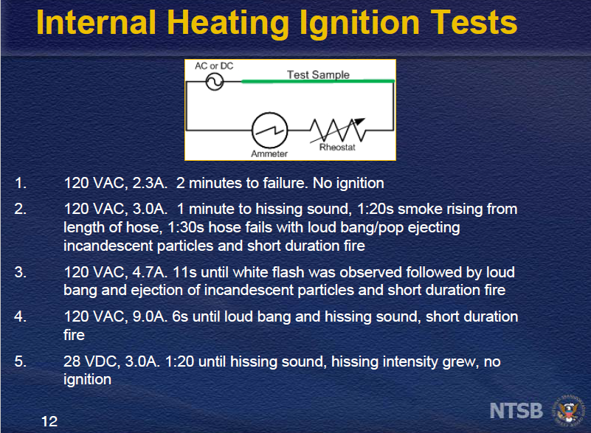
Fine, - except that it hadn't and also interesting is that the paperwork covering that Boeing approved final doubler repair had been somehow lost at both ends ...., except for a brief scribbled and abstract entry found inserted in the aircraft's maint log sheets for airframe B18255. But that fraudulent entry fooled no-one - because the evidence of no actual permanent repair was recovered from the ocean bottom after that creaky fuselage broke up at cruise-height 20 odd years later. The deeply scored rear fuselage had simply been "papered over" and the deep scoring of the tailstrike filled in and left to propagate into a spiderweb of interwoven cracks over the course of thousands of pressurization cycles. A miserable Fact.
However, notwithstanding that lurking suspicion of reflexive deceit, flawed oxygen mask hoses aren't the only way to crank up a flight-deck oxygen fire. Any spark-producing wiring insulation anomaly in close conjunction to an oxygen source, or even an oxygen leak .... that will do the job. One USAF cockpit oxy fire resulted from a pilot with a greasy face taking some therapeutic 100% oxygen as a hang-over cure. It all eventually becomes an interpretive exercise in Occam's razor. That is the maxim that says that "assumptions introduced to explain a thing must not be multiplied or extended beyond necessity". The explanations above (and in the more detailed attached treatise) abide by that principle. Simplicity remains the essence of a derived truth. The scenario needs to be disproved, not proven.
The viability and acceptability of this surmise will be quite dependent upon reading the precedent accident reports, viewing the associated imagery and then, via the exposition of the complete attached theory, extrapolating it into the critical differences of an airborne cruise height environment .... solely on the basis of known MH370 facts - and only after having done that projected analysis.
Likelihood plus precedent may fail any litigational litmus test, but it is a fierce propounder of sufficient fact …to then act.
extrapolate: to infer (an unknown) from something that is known

word count: 3708

